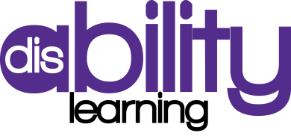

Introduction to individuals with Learning Disabilities

Whole Day
Session 1 – Define the term learning disability
10am – 11.15am

This session will explore the meaning of the term learning disabilities and how to meet individual learners support needs.

- Explore the terms MLD, SLD and PMLD
- Identify what support needs individuals with learning disabilities
- Develop strategies to support learners with diverse needs

Session 2 – Developing Communication
11.30 – 12.30

Understand how different communication tools are used and how to make learning accessible to people with learning disabilities

- Describe different communicates tools and provide examples of when these tools may be used
- Identify effective and non effective communication when supporting individuals with learning disabilities

Session 3 – Breaking down barriers
1.00pm – 2.15pm

This session will explore the negative barrier individuals with learning disabilities face and look at ways to develop a positive culture that promotes inclusion

- Explore the barriers that individuals with learning disabilities face when accessing education
- Develop strategies to overcome negative barriers
- Examine people’s attitudes and assumption and the impact this could have on a person with learning disabilities

Session 4 – Making resources accessible
2.30 – 3.30pm

Learn strategies that may be used to make learning resources clear to an individual with a learning disability

- Evaluate different resources
- Know how to use symbols and picture effectively
- Identify strategies to make resources more accessible

